**CodeMaster: A Learning Platform for Programming Languages with Integrated Compiler**

Submitted in partial fulfillment of the requirements of the degree of

**“Bachelor of Engineering”**

**In**

**Information Technology**

by

19 : Shubham Gupta

18 : Nitesh Gupta

24 : Ayush Jha

53 : Mohd Talha Faizan

Supervisor(s):

Prof. Amarja Adgaonkar



DEPARTMENT OF INFORMATION TECHNOLOGY

K.C. COLLEGE OF ENGINEERING & MANAGEMENT STUDIES & RESEARCH, THANE (E) (2024-25)

**CERTIFICATE**

This is to certify that the Mini Project entitled **CodeMaster: A Learning Platform for Programming Languages with Integrated Compiler** is a bonafide work of **Shubham Gupta-19,Nitesh Gupta -18,Ayush Jha-24,Mohd Talha Faizan-53** submitted to the University of Mumbai in partial fulfillment of the requirement for the award of the degree of **“Bachelor of Engineering”** in **“Information Technology” .**

Name and sign Name and sign

Supervisor/Guide Co Supervisor/Guide



Name and sign Name and sign

Head of Department Principal

**Project Report Approval for S.E.**

This project report entitled ***CodeMaster : A Learning platform for programming languages with integrated compiler*** by ***Shubham Gupta*** is approved for the degree of Bachelor of Engineering **Information Technology.**

Examiners

1. ---------------------------------------------

2. ---------------------------------------------

Date:

Place: Thane

**Declaration**

We declare that this written submission represents our ideas in our own words and where others' ideas or words have been included, we have adequately cited and referenced the original sources. We also declare that we have adhered to all principles of academic honesty and integrity and have not misrepresented or fabricated or falsified any idea/data/fact/source in my submission. We understand that any violation of the above will be cause for disciplinary action by the Institute and can also evoke penal action from the sources which have thus not been properly cited or from whom proper permission has not been taken when needed.

Name of student and Roll No. Signature

1.Shubham Gupta : 19

2. Nitesh Gupta : 18

3.Ayush Jha : 24

4.Mohd Talha Faizan : 53

Date:

**Declaration**

I declare that this written submission represents our ideas in our own words and

where others' ideas or words have been included, we have adequately cited and

referenced the original sources. We also declare that we have adhered to all

principles of academic honesty and integrity and have not misrepresented or

fabricated or falsified any idea/data/fact/source in our submission. We

understand that any violation of the above will be cause for disciplinary action

by the Institute and can also evoke penal action from the sources which have

thus not been properly cited or from whom proper permission has not been

taken when needed.

Name of student and Roll No. Signature

1.Shubham Gupta : 19

2. Nitesh Gupta :18

3.Ayush Jha : 24

4.Mohd Talha Faizan : 53

Date:

**ACKNOWLEDGEMENT**

We would like to express special thanks to our guide **Ms. Amarja Adgaonkar** who gave us the golden opportunity to do this wonderful project on the topic of CodeMaster: A Learning Platform for Programming Languages with Integrated Compiler which also helped us in doing a lot of research and we came to know about so many new things. We are very grateful to our Head of the Department **Ms.Amarja Adgaonkar** for extending her help directly and indirectly through various channels in our project work**.** We would also like to thank I/C Principal **Dr. Vilas N Nitnaware** for providing us the opportunity to implement our project. We are really thankful to them. Finally we would also like to thank our parents and friends who helped us a lot in finalizing this project within the limited time frame.

**TABLE OF CONTENT**

|  |  |  |
| --- | --- | --- |
| **SR NO** | **Topic** | **Page No** |
|  | **Certificate** |  |
|  | **Approval Sheet** |  |
|  | **Declaration** |  |
|  | **Acknowledgement** |  |
|  | **List of Figures** |  |
|  | **List of Table** |  |
|  | **Abstract** |  |
| **1** | **Introduction** | **1** |
| **2** | **Literature Survey** | **2** |
| **3** | **Requirement Analysis** | **3** |
| **4** | **Scope** | **3** |
| **5** | **Feasibility Study** | **3-4** |
| **6** | **Hardware & Software Requirement** | **4** |
| **7** | **Problem Statement** | **5** |
| **8** | **Project Design** | **6** |
| **9** | **Methodology** | **10** |
| **10** | **Implementation Plan** | **12** |
| **11** | **Conclusion** | **25** |
| **12** | **References** | **25** |

**List of Figures**

|  |  |
| --- | --- |
| **Sr. No.** | **Name of figure Page No.** |
| 3.3.2.1 | System Flow Chart |
| 3.3.2.2 | ER Diagram |
| 3.5.1 to 3.5.157 | Implementation and Snippets |

**List of Tables**

|  |  |
| --- | --- |
| **Sr. No.** | **Name of table Page No.** |
| 2.1 | Literature Survey 2 |

**ABSTRACT**

This project presents the development of an interactive coding learning platform designed to teach users programming languages such as C, C++, Java, and Python. The application offers a structured, chapter-wise learning experience, providing comprehensive notes and a series of coding questions. Users can attempt these questions directly within the app using an in-built compiler that supports all four languages. This platform aims to provide an all-in-one solution for both learning and practicing coding, catering to beginners and intermediate users, enhancing their programming skills through an intuitive and user-friendly interface.

**INTRODUCTION**

In today’s rapidly evolving digital world, the demand for programming skills has grown exponentially. As technology becomes more integrated into daily life and various industries, there is an increasing need for platforms that can provide effective, accessible, and engaging ways to learn programming. This project aims to address that need by developing a coding learning application that offers a structured approach to learning four widely-used programming languages: C, C++, Java, and Python.

The platform is designed with both beginners and intermediate learners in mind, providing chapter-wise notes to build foundational knowledge, followed by coding questions to apply and reinforce learning. Users can practice solving these questions directly within the application through its in-built compiler, making the process of coding both seamless and interactive. The ability to switch between languages allows users to gain proficiency in multiple languages, broadening their skill set.

To enhance user management, the application is integrated with a database that records each user's details. While it does not track progress at this stage, it ensures that user information is securely stored, which opens up possibilities for future improvements like personalized learning paths or performance tracking.

The combination of educational resources, coding practice, and language support makes this platform a comprehensive tool for anyone looking to start or improve their programming skills. With a user-friendly interface and the integration of key programming languages, this project provides a solid foundation for learning to code efficiently and effectively.

**2. Review of Literature**

| **Year of Paper** | **Title of the Paper** | **Methodology of Paper** | **Advantages** | **Limitations** |
| --- | --- | --- | --- | --- |
| 2015 | A Novel Approach to Coding Education | Developed a web-based platform integrating exercises with tutorials. | Seamless integration of tutorials and exercises. | Limited to one programming language (Python). |
| 2017 | Improving Online Learning for Coders | Used data analytics to provide personalized content to learners. | Personalized learning paths improve user engagement. | High server costs for data processing. |
| 2019 | Interactive Coding Platforms for Beginners | Built an interactive, gamified platform with real-time code validation. | Real-time feedback encourages hands-on learning. | Requires constant internet connection. |
| 2022 | Optimizing Compiler Performance in Educational Tools | Implemented local compiler optimization techniques to reduce execution time. | Faster code execution enhances user experience. | Complicated setup for non-technical users. |

**3. Report on Present Investigation**

**3.1 Requirement Analysis**

**3.1.1 Scope**

The scope of the project encompasses the development of an interactive coding learning application that aims to provide users with a comprehensive platform for learning programming languages (C, C++, Java, and Python). The key features include:

1. Chapter-wise Learning Materials: Users will have access to structured notes covering essential concepts in each programming language.
2. Coding Challenges and Exercises: The application will include a variety of coding questions and exercises that users can solve within the app.
3. Integrated Compiler: Users will be able to write, compile, and execute code directly within the application, facilitating a hands-on learning experience.
4. User Database Management: The application will incorporate a database to store user details, enabling personalized learning experiences and user management.
5. Future Enhancements: Potential expansions could include progress tracking, advanced coding challenges, and community features for peer interaction.

**3.1.2 Feasibility Study**

Technical Feasibility:

* Technologies: The use of widely adopted technologies such as JavaFX for the front end and a relational database (like MySQL or myPhp) for user data storage is practical and sustainable.
* Development Resources: Available resources include programming knowledge, development tools, and frameworks that support rapid development.

Economic Feasibility:

* Budgeting: An initial budget can be estimated for development, including costs for software licenses, hosting, and potential marketing.
* Cost-Benefit Analysis: By evaluating expected user engagement and potential revenue (if monetized), the project is expected to be economically viable.

Operational Feasibility:

* User Demand: There is a growing demand for coding education tools among students and professionals seeking to enhance their programming skills.
* Ease of Use: The application is designed to be user-friendly, ensuring accessibility for individuals with varying levels of programming experience.

**3.1.3 Hardware and Software Requirements**

For optimal performance of the coding learning application, the following hardware requirements are recommended:

**Client-Side Requirements:**

1. Processor: Minimum dual-core processor (e.g., Intel i3 or equivalent).
2. RAM: At least 4 GB of RAM (8 GB recommended for better performance).
3. Storage: Minimum of 500 MB of available disk space for the application and additional space for user data.
4. Graphics: Integrated graphics that support JavaFX applications.

**Server-Side Requirements (if hosted on a dedicated server):**

1. Processor: Quad-core processor (e.g., Intel Xeon or equivalent).
2. RAM: Minimum 16 GB of RAM (32 GB recommended for handling multiple user sessions).
3. Storage: SSD with a minimum of 100 GB of available space for the database and application data.
4. Network: High-speed internet connection with bandwidth to handle concurrent users.

**3.2 PROBLEM STATEMENT**

The problem statement is Building a learning app with intuitive and user friendly UI for users with seamless experience.

**Objectives:**

* **Create an engaging learning experience**: Develop an intuitive platform where users can easily learn and practice coding in C, C++, Java, and Python, with a focus on user-friendliness.
* **Provide structured learning paths**: Offer well-organized, chapter-wise notes that guide learners through the basics to more advanced concepts, giving them a clear roadmap to follow.
* **Facilitate hands-on practice**: Integrate a built-in compiler that allows users to write, run, and test code within the application, encouraging active learning.
* **Personalize user experience**: Record and manage user details using a database, allowing for future personalization, such as tracking individual progress and tailoring content to user needs.
* **Support multiple languages in one platform**: Consolidate learning for C, C++, Java, and Python, offering a single space for users to switch between languages and broaden their skillset.

**3.3 PROJECT DESIGN**

**3.3.1 Proposed Algorithm**

***Frontend (Client Side):***

1. **User Login & Registration:**

Users can register or log in to the application via a graphical interface.

User details are captured and sent to the backend for verification and storage.

1. **Chapter Selection:**

Users select a programming language and a specific chapter to study.

The relevant notes and materials for the chapter are fetched from the database and displayed to the user.

1. **Code Input:**

Users write code directly in the integrated code editor for the chosen language (C, C++, Java, Python).

The code is saved locally and formatted for local compilation.

1. **Submit Code for Compilation:**

Users click a button to submit their code for compilation.

The code is passed to the appropriate compiler (e.g., GCC for C/C++) pre-installed on the user’s local machine.

1. **Display Compilation Results:**

After compilation, the results (output or errors) are captured and displayed within the GUI.

Any compilation or runtime errors are displayed to the user for correction.

***Backend (Server Side):***

1. **User Data Management:**

The backend stores and manages user information such as registration details, language preferences, and activities (e.g., login times, chapter views).

1. **Chapter Content Delivery:**

The backend delivers the chapter-wise content (notes, questions) by retrieving data from the database.

1. **Store User Submissions:**

User submissions are optionally stored in the backend for tracking purposes (though code is executed on the client side).

***Code Execution (Client Side):***

1. **Local Compilation:**

The application triggers local compilation using pre-installed compilers such as:

GCC for C and C++.

Java Development Kit (JDK) for Java.

Python Interpreter for Python.

The local environment handles the execution of the code.

1. **Capture and Display Results:**

The local machine captures the output or errors from the compiler.

Results are displayed to the user in real-time.

1. **Database:**

Store Chapter Content and User Data:

The database stores chapter-wise learning materials, questions, and user information.

Data about user activities (e.g., which chapter they accessed, attempted questions) is recorded.

1. **Admin Panel:**

Manage Content:

Admins can add or edit chapter content and questions through a dedicated admin panel.

Content updates are stored in the database.

**3.3.2.1 Flowchart**

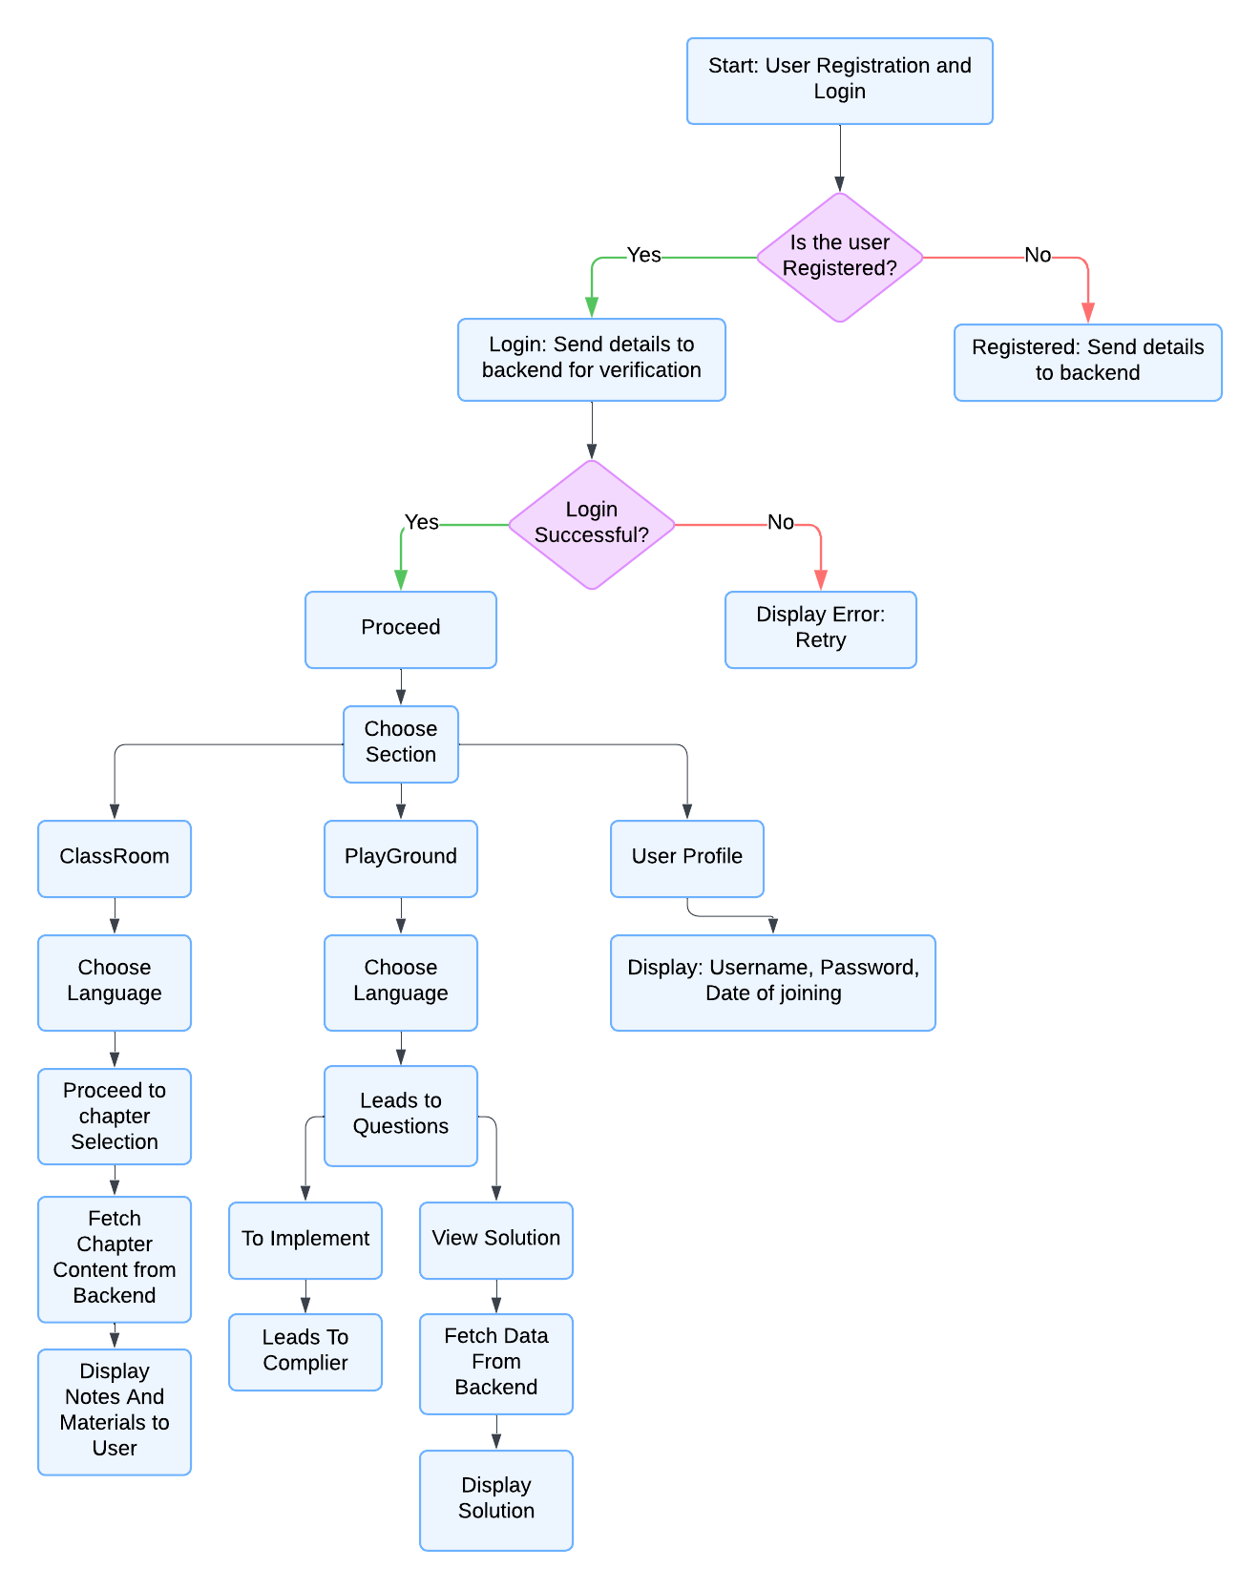

**3.3.2.2 ER DIAGRAM**

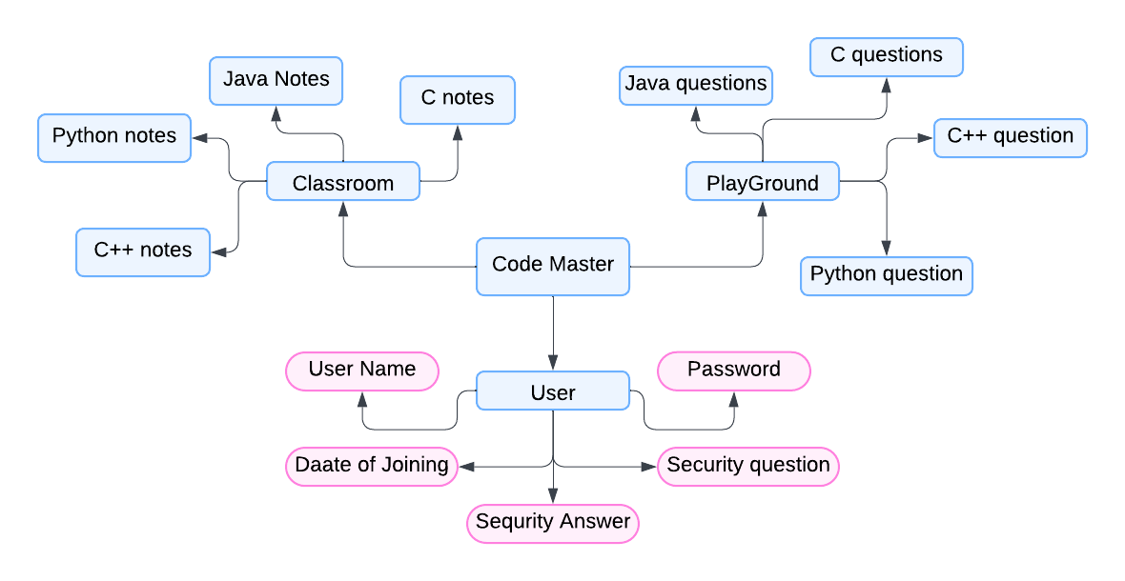

**3.4 Methodology**

The development of the coding learning platform utilized several key technologies and processes to provide a seamless user experience for coding education. This methodology integrates JavaFX for building the user interface, Scene Builder for creating the layout, and pre-installed compilers for code execution. Each component of the application plays a vital role in achieving the desired functionality across frontend, backend, and local code compilation.

***1. Frontend Development with JavaFX and Scene Builder***

JavaFX was chosen as the core technology for the frontend, as it offers a flexible, modern framework for building rich graphical user interfaces in Java. JavaFX allows for a responsive and interactive design, essential for a learning platform where users will frequently interact with the UI to navigate chapters, input code, and view results. Key JavaFX features such as built-in UI controls, animation, and CSS support were leveraged to enhance the application's aesthetics and usability.

To streamline the UI development process, Scene Builder was integrated into the workflow. Scene Builder is a drag-and-drop interface tool for JavaFX that allows developers to visually design the layout of the application's windows (called "scenes"). By using Scene Builder, the design process became more efficient, allowing for rapid prototyping and iteration on the user interface. The FXML files generated by Scene Builder were used to control the structure of different components in the application—such as login screens, chapter navigation, and the code editor interface—enabling easier linking between the visual elements and the underlying logic in Java.

***2. Code Editor Integration and Input Handling***

A custom code editor was integrated within the JavaFX interface to allow users to write and test code in multiple programming languages, including C, C++, Java, and Python. This editor includes basic functionalities such as syntax highlighting and line numbering, providing users with a familiar environment similar to professional IDEs. The input from the editor is captured in real-time, and users can easily submit their code for compilation with the click of a button.

The user interface is structured to allow chapter selection, question attempts, and code input without overwhelming the user. When a user selects a chapter, relevant study materials and exercises are loaded from the backend and displayed on the screen. Users can then type or paste their code in the integrated editor to solve the provided problems.

***3. Backend Architecture and Database Management***

The backend architecture was designed to manage user accounts, store content, and retrieve data dynamically based on user actions. A relational database (e.g., MySQL) was used to store information about users, chapters, questions, and notes. This database handles tasks like user authentication (login/registration), saving user preferences, and providing tailored content when a user selects a language or chapter.

The backend also allows admins to upload or update educational content such as notes and exercises through an admin interface. All these updates are stored in the database, making it easy to maintain and expand the platform with new chapters or exercises.

***4. Local Code Compilation***

One of the standout features of the application is its use of locally pre-installed compilers to execute code instead of relying on online APIs. This decision ensures that users have direct control over their coding environment, simulating real-world coding practices. For each language, the following tools are used:

GCC (GNU Compiler Collection) for compiling and executing C and C++ programs.

Java Development Kit (JDK) for compiling and running Java code.

Python Interpreter for executing Python scripts.

When the user submits code from the editor, the application passes the code to these local tools. The system uses native commands to compile the code and capture the output (or errors). These results are then displayed in the application interface, allowing the user to correct errors or review successful output. This approach not only ensures reliability but also provides users with a real-time coding experience similar to working in a standalone IDE.

***5. User Data Management and Progress Tracking***

While the application does not track user progress in terms of completed chapters or solved exercises at this stage, it does maintain detailed records of user interactions such as logins, language preferences, and any submissions made through the code editor. The application’s database structure is designed to allow easy integration of future features, such as progress tracking, performance analytics, and personalized recommendations based on user behavior.

***6. System Enhancements for Admins***

The admin interface enables administrators to manage the platform's educational content without direct interaction with the backend code. This interface was also built using JavaFX, allowing administrators to:

Add or edit chapter-wise notes and coding exercises.

Monitor user activity and performance through queries to the database.

This modular approach ensures that the platform remains scalable, adaptable, and maintainable over time.

**3.5 Implementation**

We started by improving upon the shortcomings of the existing system and implementing those improvements accordingly in the application.

Improvements include :

- Ensuring lite-weight and minimal implementation for deployment on low end machines.

- Ensuring proper documentations for building and deployment.

- Cross platform support through single executable jar files.

- Dedicated server to store and retrieve orders from database to ensure 24x7 service of our platform.

● The project was divided into 3 parts with Faizan handling the JDBC connectivity,

Nitesh Gupta and Ayush Jha - Front-end designing and implementation using JavaFx, CSS, Java & other UI resources and Shubham Gupta handling the Backend , Documentation, Project Layouts, Database Handling, Java base classes & Presentation aspects.

● We divided the tasks amongst us and had set deadlines to complete the certain code blocks at a given amount of time. With that, the GUI aspects were done simultaneously by every member of the team.

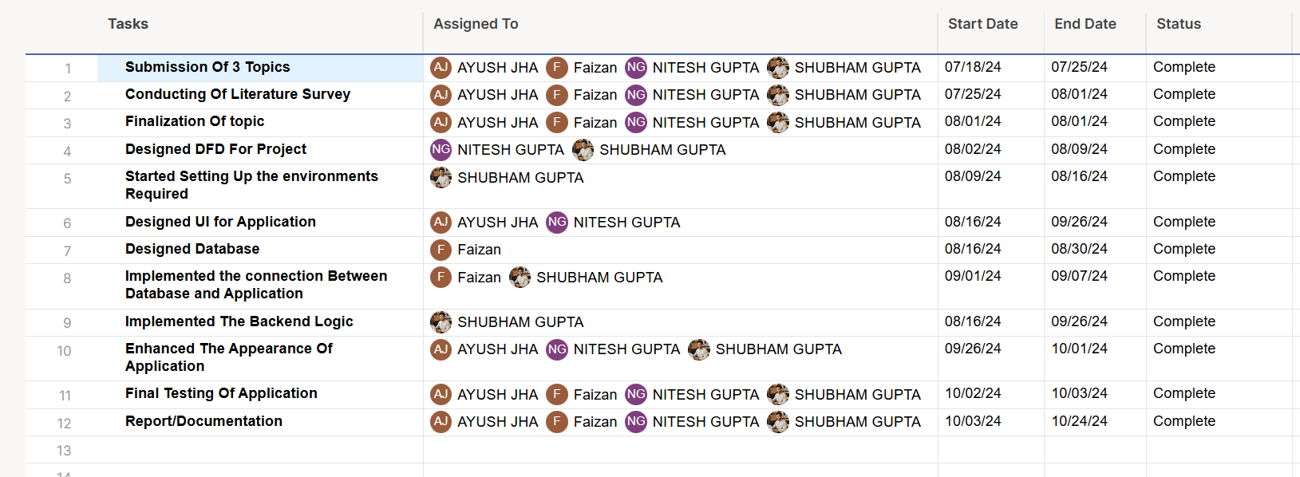



**Fig 3.5.1: Tasks performed in the month of July**

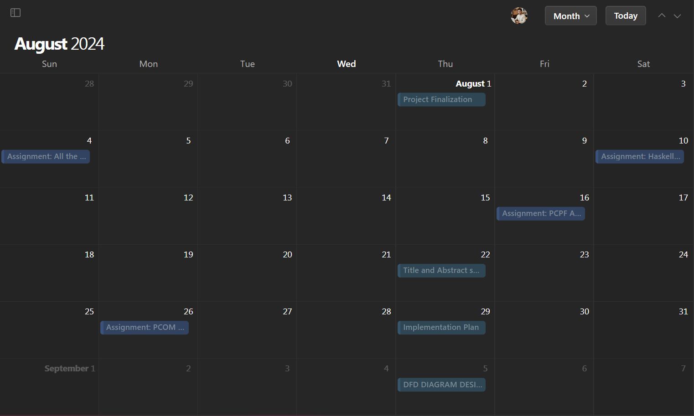

**Fig 3.5.2 : Tasks performed in the month of August**

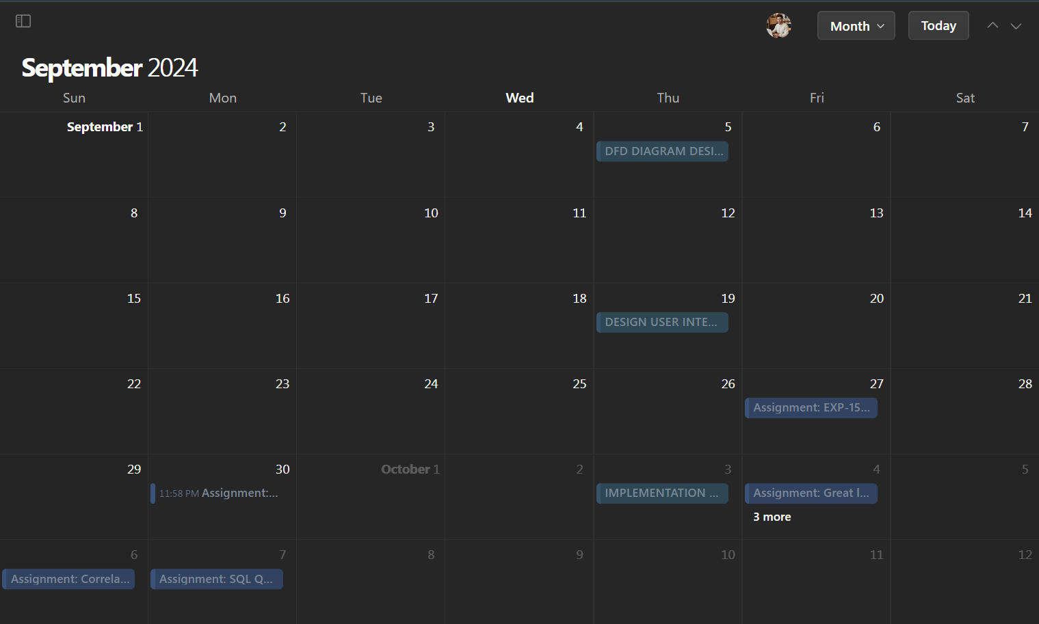

**Fig 3.5.3 : Tasks performed in the month of september**

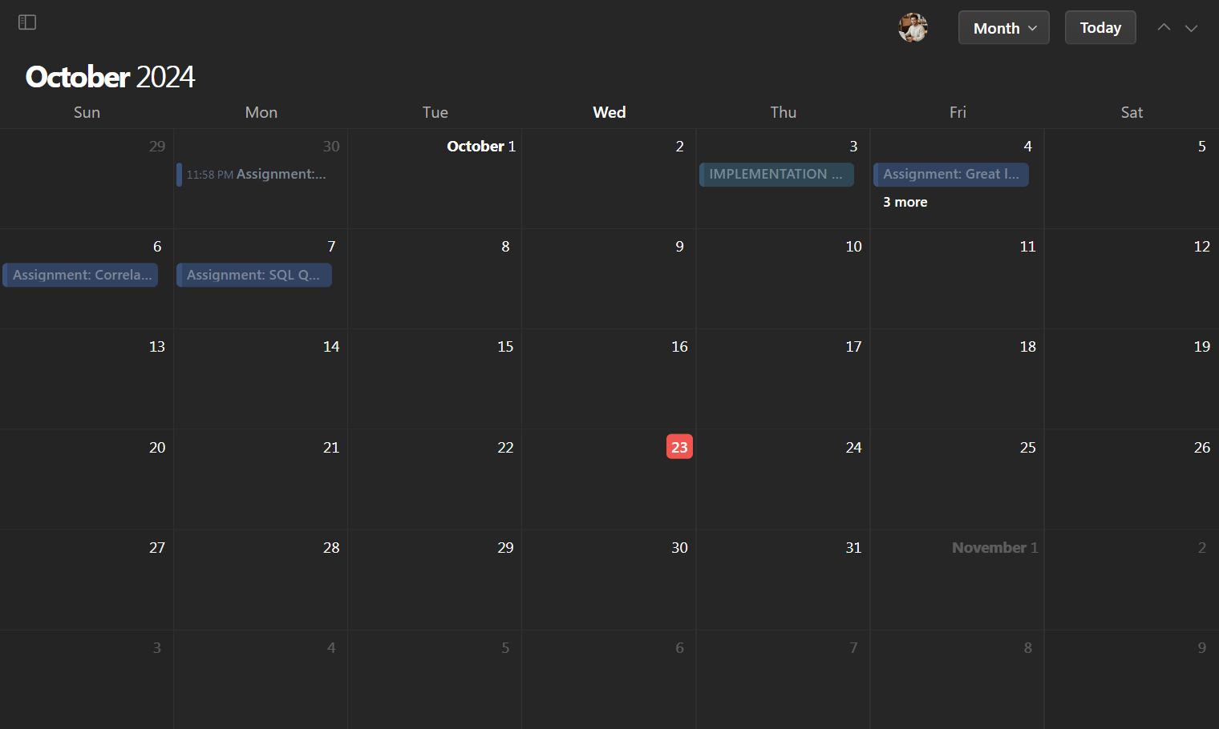

**Fig 3.5.4 : Tasks performed in the month of October**

**Advantages:**

1. **Cost-effective**: Uses local compilers, reducing reliance on expensive cloud APIs.
2. **User-friendly**: JavaFX provides a smooth, interactive interface.
3. **Multi-language support**: Covers C, C++, Java, and Python, appealing to a broad audience.
4. **Offline functionality**: No constant internet required for code execution.
5. **Scalable**: Easy to add features like progress tracking and analytics in the future.
6. **Content management**: Admins can update content without needing deep technical knowledge.

### Disadvantages:

1. **Requires local setup**: Users need to install compilers, which may be a barrier.
2. **Limited cloud capabilities**: No seamless cross-device code execution.
3. **No progress tracking**: Currently lacks personalized learning experiences.
4. **Competition**: Strong competition from cloud-based platforms.
5. **Maintenance**: Dependency on updates to local compilers adds complexity.

**Code Snippets :**

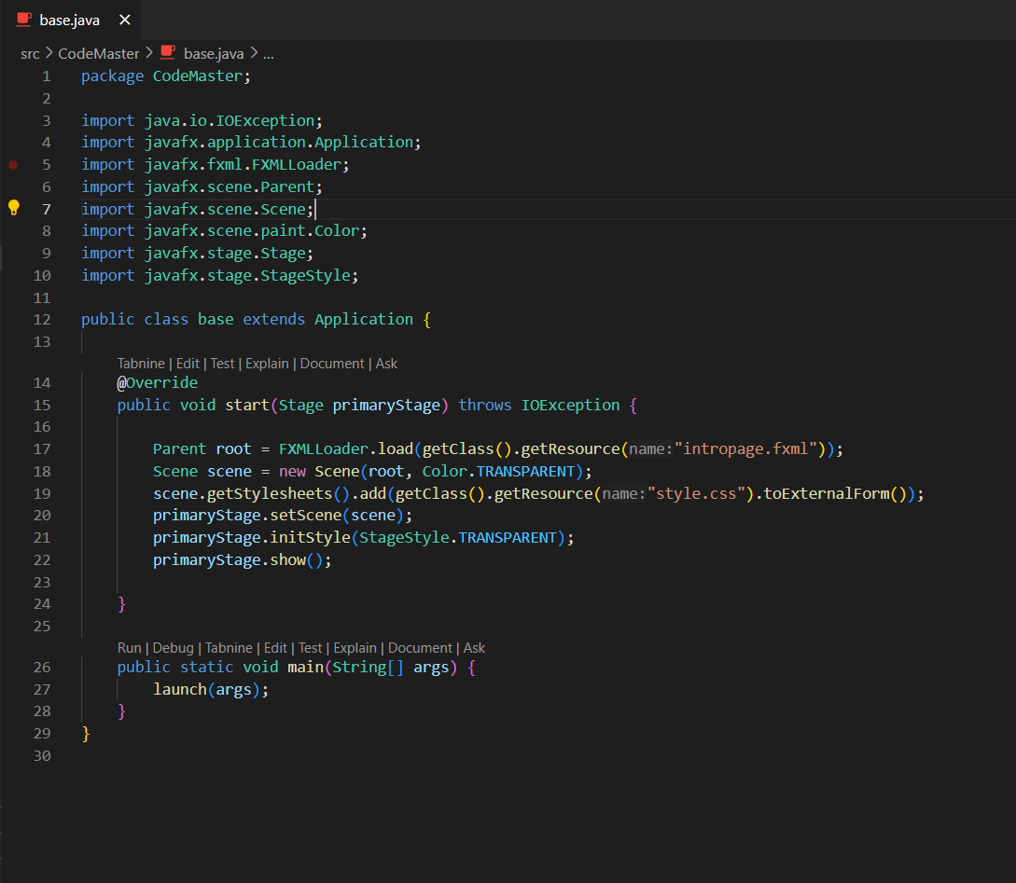

**Fig 3.5.4 : Main Method**

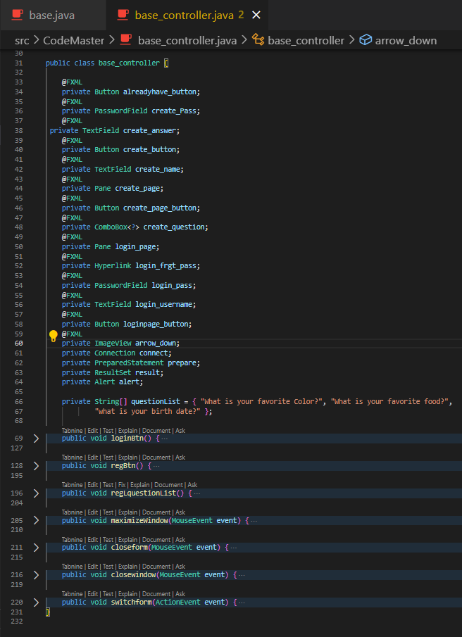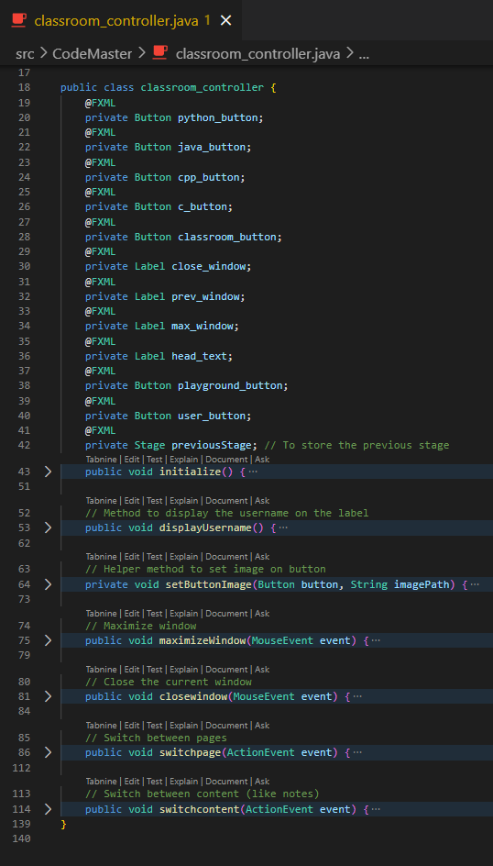

**Fig 3.5.7 : Controller Classes**

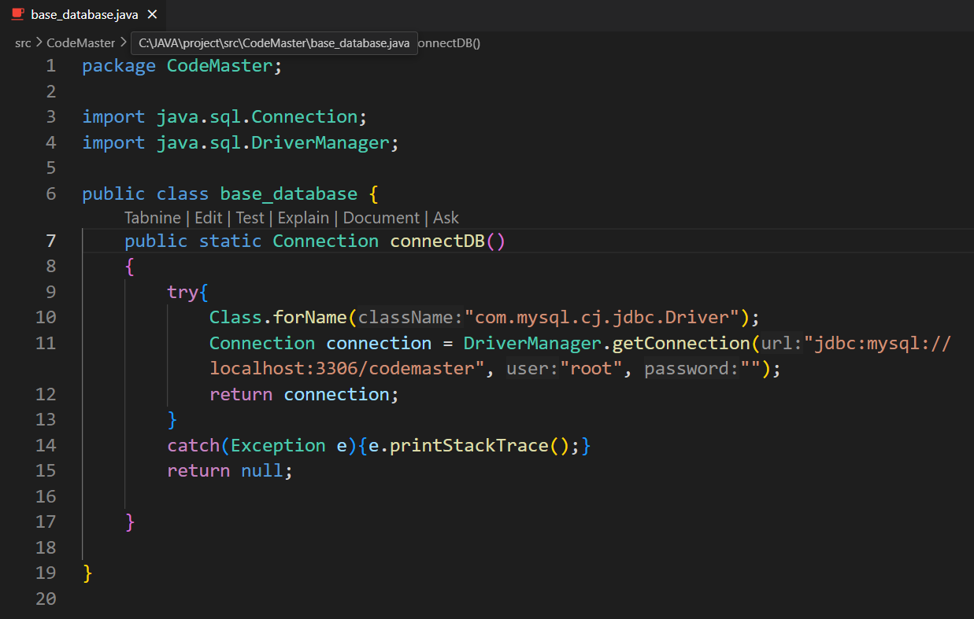

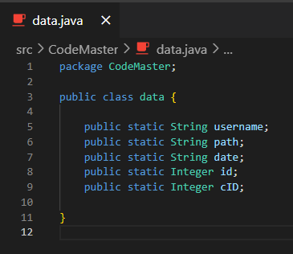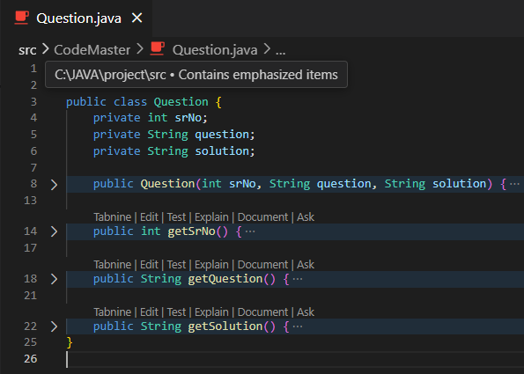

**Fig 3.5.7 :Code For Connection with Database**

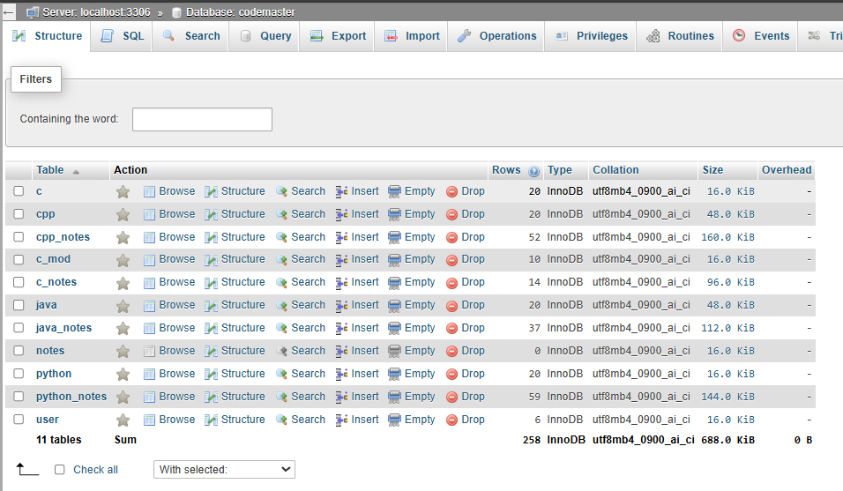

**Fig 3.5.8 : Database**

**GUI Snippets**:

These are images of actual working of app

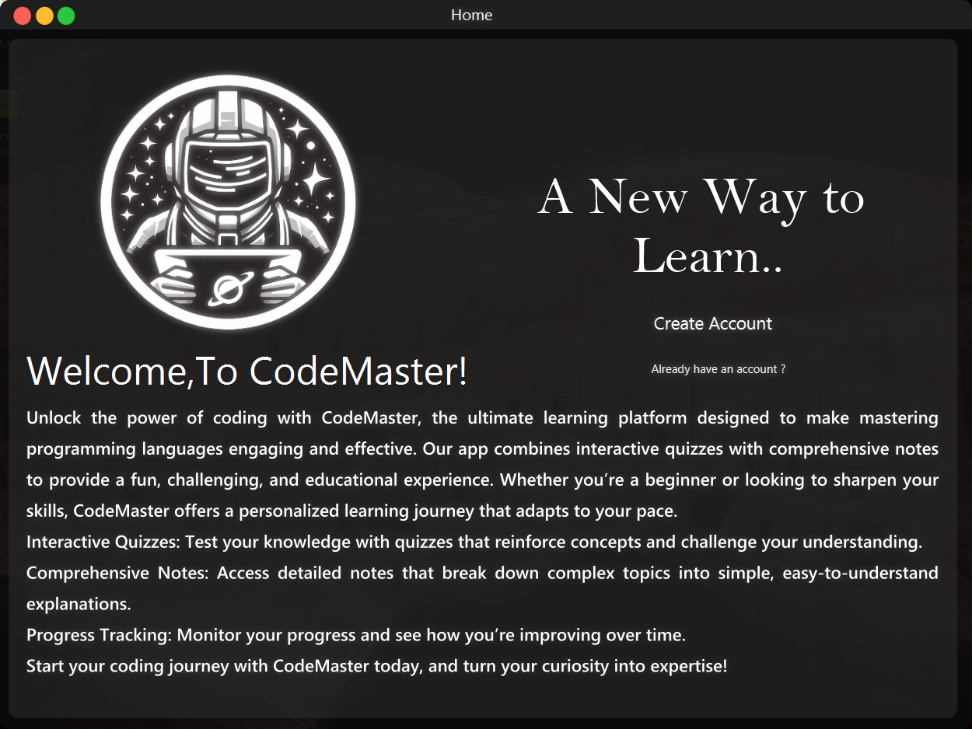

**Fig 3.5.9 : Main Screen**

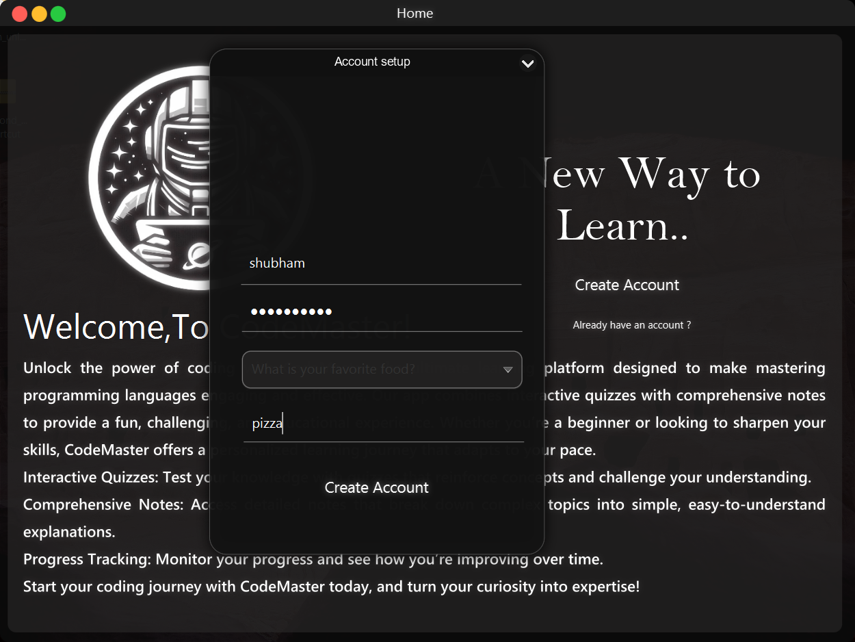

**Fig 3.5.10 : Interface For Creating New Account**

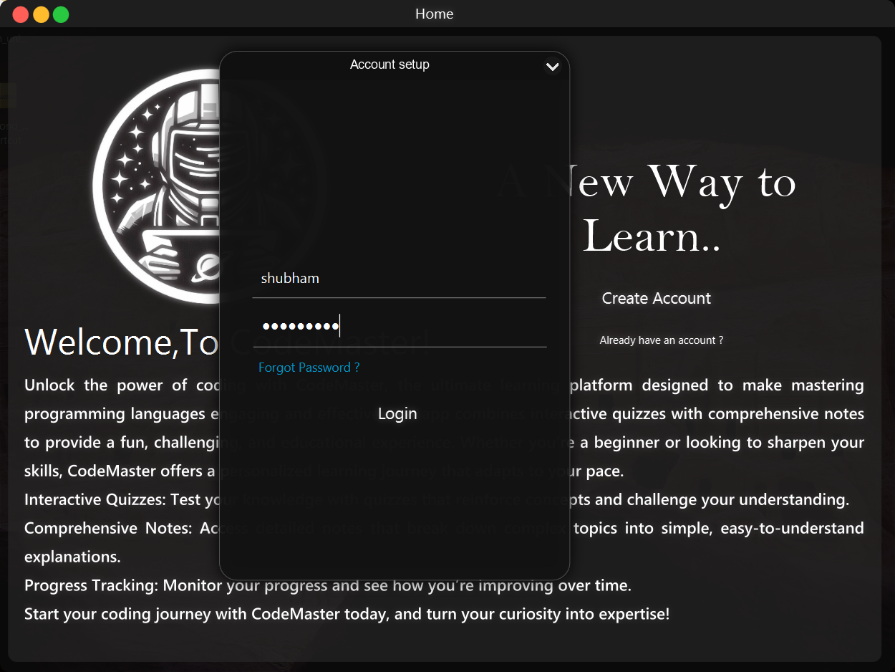

**Fig 3.5.11 : Interface For Logging Into Account**

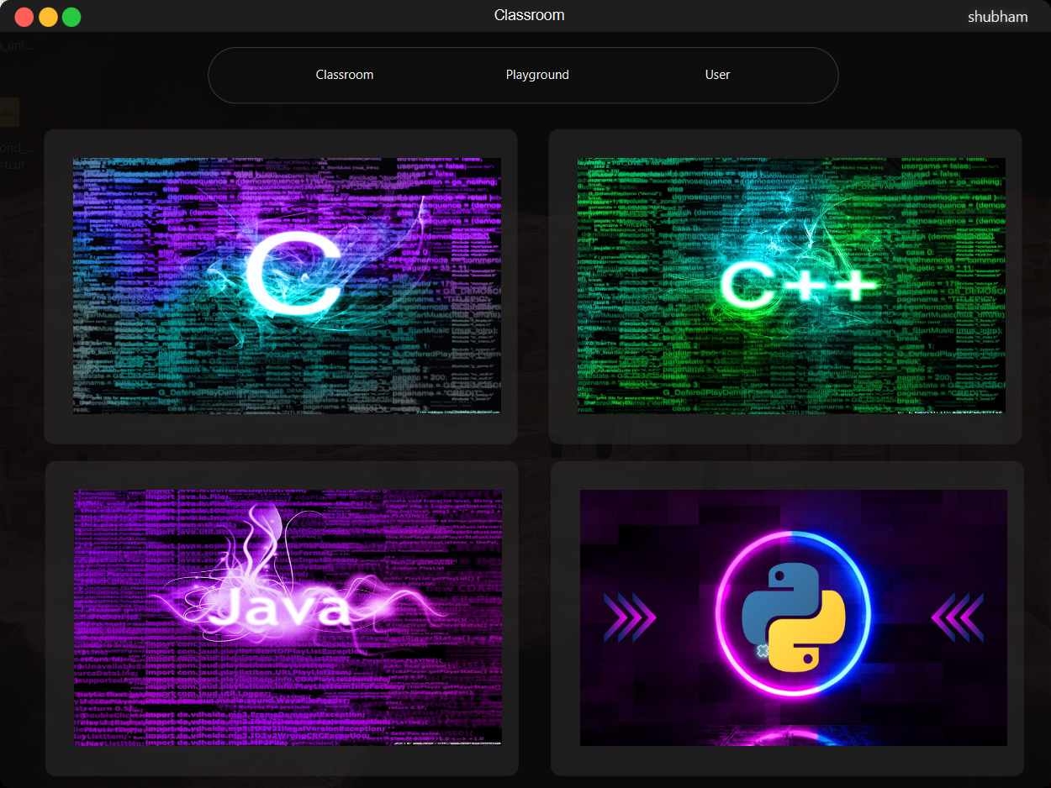

**Fig 3.5.12 : Interface For Classroom**

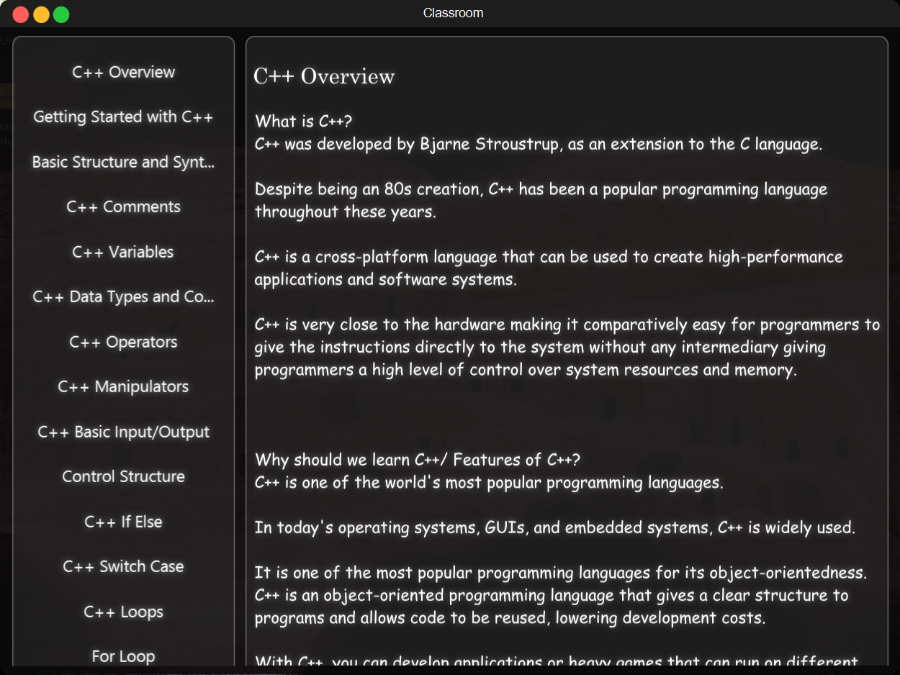

**Fig 3.5.13 : Interface For Viewing Notes**

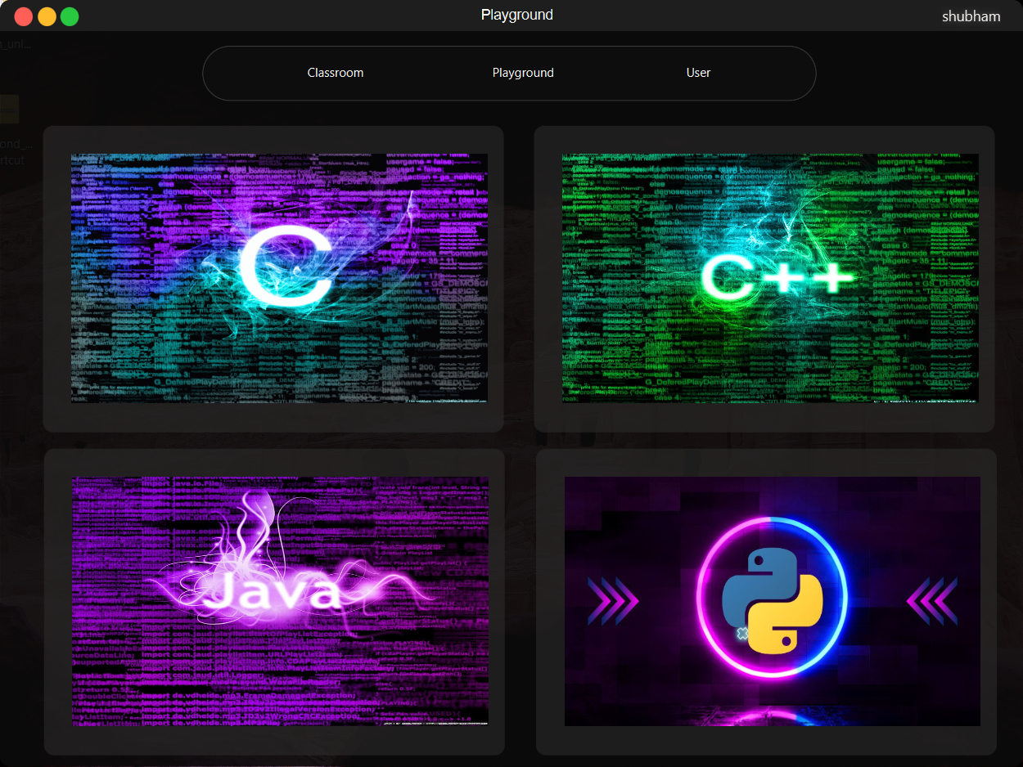

**Fig 3.5.14 : Interface For Playground**

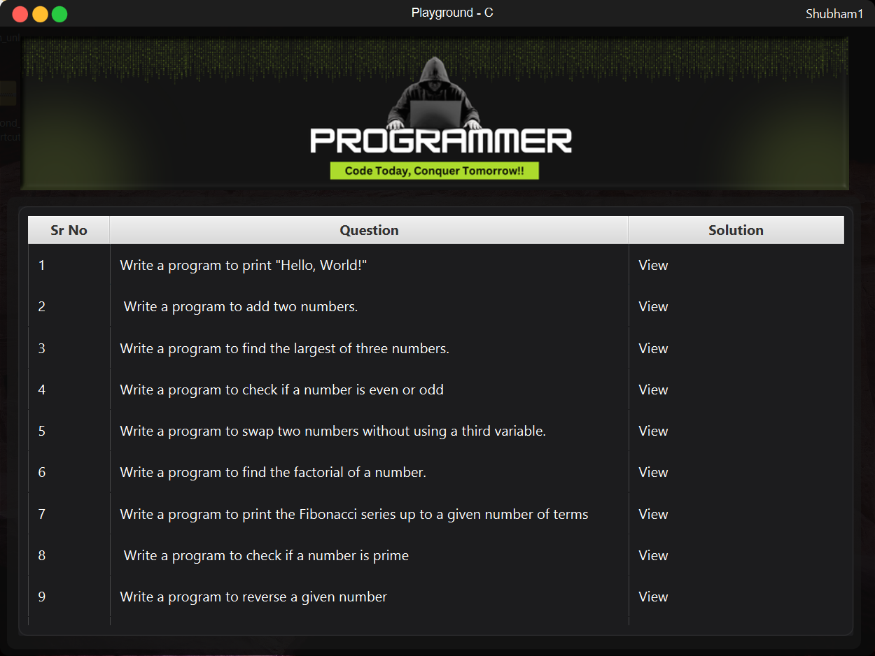 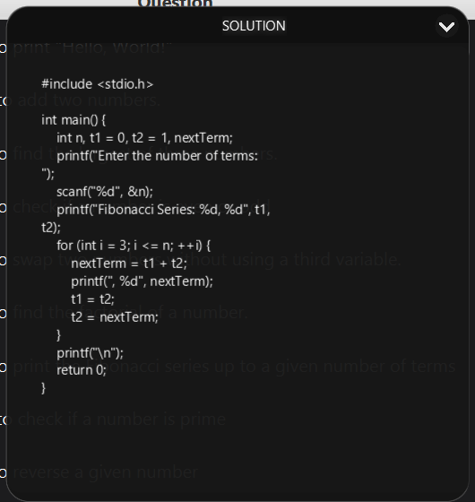

**Fig 3.5.15 : Interface For Viewing Questions Fig 3.5.16 : Interface For Viewing Solution**

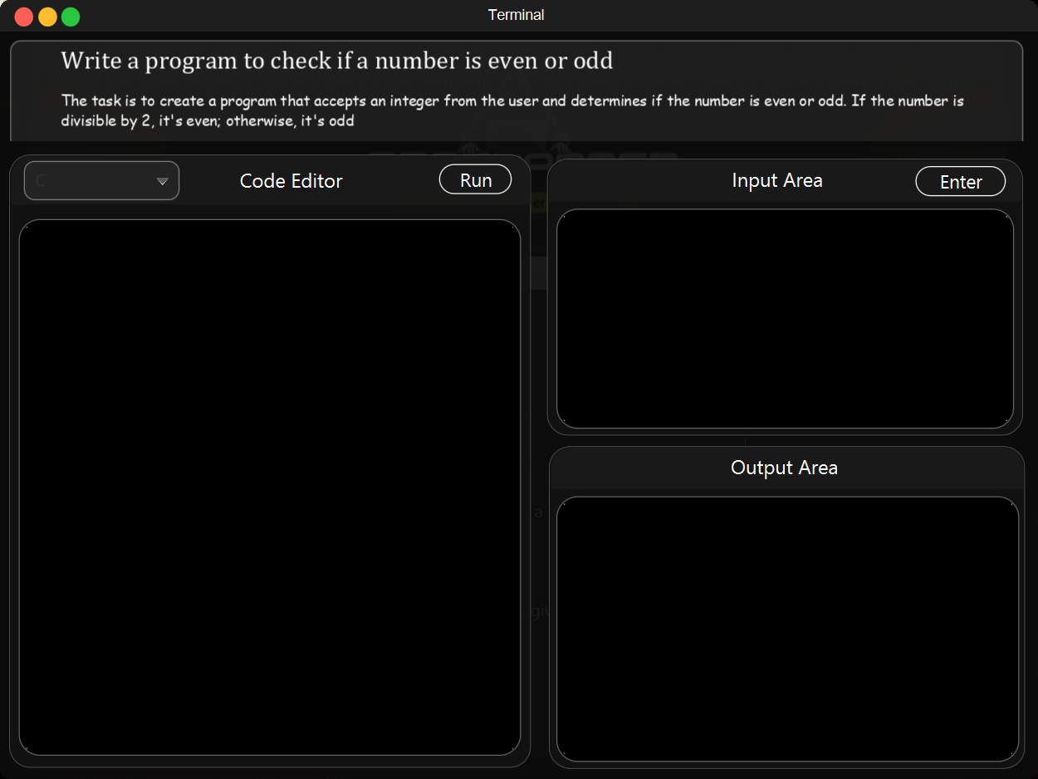

**Fig 3.5.17: Interface For Compiler**

**4.CONCLUSION**

The coding learning platform developed successfully integrates key technologies like JavaFX, Scene Builder, and local compilers (GCC, JDK, Python interpreter) to provide users with a practical and interactive learning environment. It offers multi-language support and allows users to practice coding with real-time execution without requiring constant internet access, giving it a distinct edge in certain markets.

The project highlights efficient frontend design, strong backend functionality, and the seamless integration of local compilers, making it both cost-effective and scalable. While the current system is focused on providing a solid foundation for coding education, the architecture leaves room for future enhancements like progress tracking and personalized learning, which can further increase user engagement and the platform's market value.

With its modular design and focus on user experience, this platform stands as a robust solution for learners looking to improve their coding skills across various programming languages.

**5.REFERENCE**

1. **Codecademy** – <https://www.codecademy.com/>
2. **freeCodeCamp** – <https://www.freecodecamp.org/>
3. **GeeksforGeeks** – <https://www.geeksforgeeks.org/>
4. **Coursera** – <https://www.coursera.org/>
5. **Khan Academy (Computer Programming)** – <https://www.khanacademy.org/computing/computer-programming>
6. **W3Schools** – <https://www.w3schools.com/>
7. **edX (Computer Science Courses)** – https://www.edx.org/learn/computer-science
8. **HackerRank** – <https://www.hackerrank.com/>
9. **LeetCode** – <https://leetcode.com/>
10. **Udemy (Programming Courses)** – https://www.udemy.com/topic/programming-languages/
11. **Stack Overflow** – <https://stackoverflow.com/>
12. **GitHub** – <https://github.com/>
13. **Real Python** – <https://realpython.com/>
14. **JavaTPoint** – <https://www.javatpoint.com/>
15. **TutorialsPoint** – <https://www.tutorialspoint.com/>
16. **Programiz** – <https://www.programiz.com/>
17. **Sololearn** – <https://www.sololearn.com/>
18. **Educative** – <https://www.educative.io/>
19. **MIT OpenCourseWare** – <https://ocw.mit.edu/>
20. **CS50 (Harvard's Intro to Computer Science)** – <https://cs50.harvard.edu/>